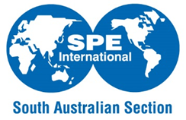
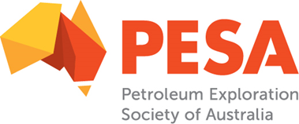

2020 Joint PESA-ASEG-SPE Mentoring Program, SA Branch
Registration of Expression of Interest
BACKGROUND INFORMATION
First Name
Last Name
PESA, ASEG or SPE Member
Gender: | Female | Male |  | Prefer Not to Answer
Major Technical Discipline
Employer
Position or
Postgraduates: (Masters, PhD) Research Topic
No. Year’s Experience
Company Type: (eg E&P, Contractor, Service Co, Consultancy, Research)
Email
Phone No.

REGISTER AS:
Mentor
Mentor – willing to have more than one mentee
Mentee

Main Area of Expertise

Briefly describe your main area of expertise, career background, and your strongest competencies (technical and non-technical knowledge, skills).

Mentees Only

Briefly describe current and future areas of interest in the petroleum and/or natural resource industry, key competencies which you like to strengthen and main objectives for participation in this program. If applicable, indicate any particular mentor skills or background experience which you think would complement your requirements.

Main Interests Outside of Work

Briefly list your main interests/hobbies outside of work.

Mentor/Mentee Preference
For matching purposes, please indicate if you have a preference:
Geologist
Geophysicist
Engineer
No Preference

Thank you for your Expression of Interest in the Joint PESA-ASEG-SPE SA Mentoring Program and the time taken to complete the registration form is appreciated very much. Please submit this form to Lewis Maxwell, YPP SA President, Lewis.Maxwell@santos.com by COB December 6th 2019.

We will aim to notify applicants regarding acceptance into the program by January 17th 2020 following determination of mentee/mentor pairs.

