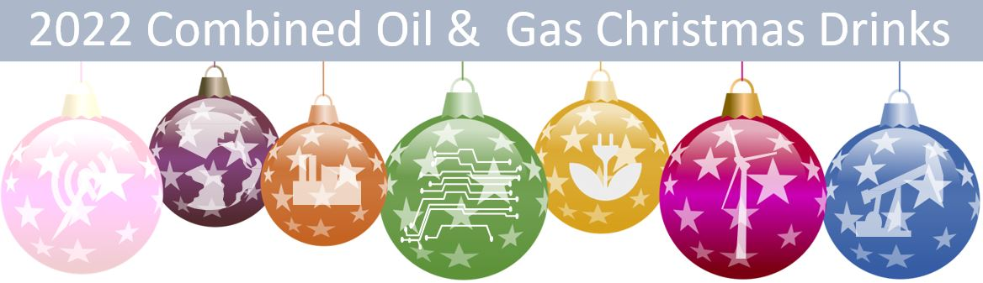

SPONSORSHIP OPPORTUNITY

The Combined Industry Christmas event is on again. Thursday 24 November, 5.30 to 9pm at the Port Office, Level 2 (enter via Margaret Street)
We are offering limited sponsorships for this event at $1000.
This includes -
- 4 x complimentary tickets
- 2x banners on display
- Logos on further communication and displayed on screens at the event.
If you are interested please contact QUPEXsecretary@slrconsulting.com for payment details.

